GLENIFFER HIGH SCHOOL  Amochrie Road  Paisley PA2 0AG  Tel: 0300 300 1313  Email address: glenifferhighenquiries@renfrewshire.gov.uk  Website: www.glenifferhigh.renfrewshire.sch.uk  Head Teacher: Lisa Chalmers | Children’s Services
Our Ref: DMS3Exam
Date: 02 April 2026

S3 Exams

Dear Parent/Carer
S3 Exams will take place on 27th April until the 11th of May.
Pupils will follow their normal school timetable and assessment blocks will take place during double periods in the subject which corresponds to their column choice outlined below.
Pupils will not be given study leave for these exams and should follow their normal timetable when not undertaking an assessment.
Pupils should be in full school uniform and come to exams readily equipped (pencils/pens/calculators as appropriate).
These exams are under exam conditions and therefore pupils will not be allowed to have access to their mobile phones and or smart watches alongside personal belongings (bags/jackets etc.) these will be stored safely in the classroom away from their examination table.
All learners who are entitled to additional arrangements during assessment periods will have this factored into their examinations in class by their class teacher.
Help with studying approaches can be found via this link:
https://www.glenifferhigh.renfrewshire.sch.uk/news/get-exam-ready/
The best advice and support will come from their class teachers; this is where pupils should start with guidance on approaches for their subject area.

SUBJECTS IN EACH COLUMN:
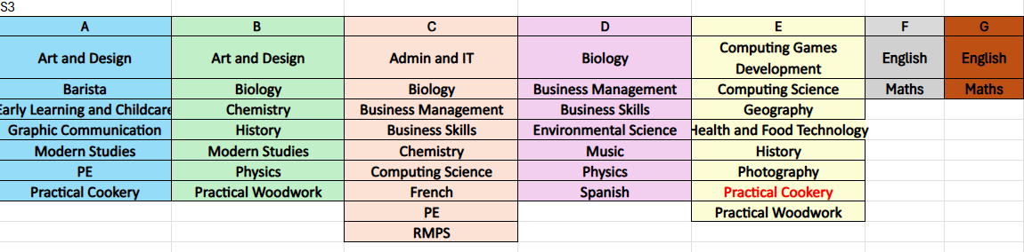
Below is the timetable which indicates when the assessments will take place each day for each subject. Exams will take place within a double period block, with exception of subjects in Column’s B, D and G. These subjects will need time during their ‘core classes’ to complete their assessments. This may mean attending a subject 1 period earlier or later than normal. Practical Cookery in column E has been postponed until 19th May.
The exam structure means that pupils are sitting exams in the subjects they normally attend during this time. E.g. Wednesday period 1 and 2 means that all subjects in column A will have an exam. This is the subject that the pupil normally attends on a Wednesday P1 and P2.
EXAM TIMETABLES
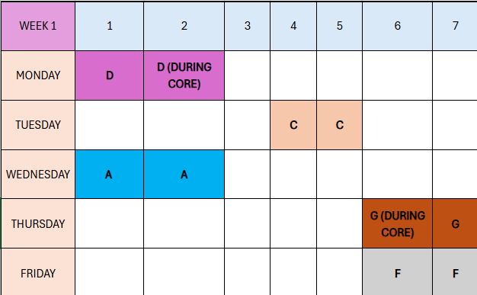
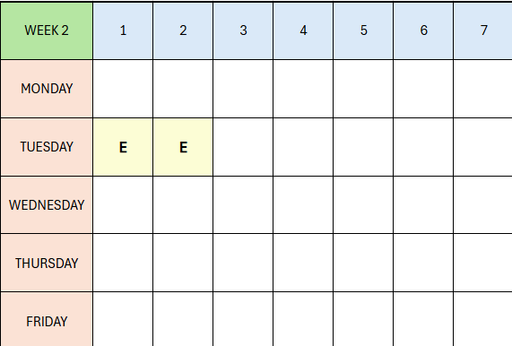
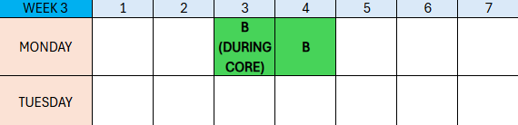

If you have any further questions about this, please do not hesitate to get in touch.

Kind Regards
Debbie Martin
Debbie Martin
DHT Brodie House
SQA Coordinator and Attainment
