GLENIFFER HIGH SCHOOL  Amochrie Road  Paisley PA2 0AG  Tel: 0300 300 1313  Email address: glenifferhighenquiries@renfrewshire.gov.uk  Website: www.glenifferhigh.renfrewshire.sch.uk  Head Teacher: Lisa Chalmers | Children’s Services

Our Ref: DM
Date: 28/01/26

Senior Phase Assessment Block

Dear Parent/Carer,

The Final S5 and S6 Assessment Block will commence on the 19^{th of} February.
Pupils will follow their normal school timetable and assessment blocks will take place during double periods in the subject which corresponds to their column choice outlined below. There are a couple of exceptions to this, given the nature of the assessment during this block and I have outlined these in this letter. Higher English and Higher PE will also take place in the games hall to give learners the ‘exam experience’ ahead of the formal SQA diet.

Expectations:
- Pupils will not be given study leave for these exams and should follow their normal timetable when not undertaking an assessment.
- Pupils should be in full school uniform and come to exams readily equipped (pencils/pens/calculators as appropriate).
- These exams are under exam conditions and therefore pupils will not be allowed to have access to their mobile phones and or smart watches alongside personal belongings (bags/jackets etc.) these will be stored safely in the classroom away from their examination table.
All learners who are entitled to additional arrangements during assessment periods will have this factored into their examinations in class by their class teacher.

Help with studying approaches can be found via this link:
https://www.glenifferhigh.renfrewshire.sch.uk/news/get-exam-ready/

The best advice and support will come from their class teachers, this is where pupils should start with guidance on approaches for their subject area.

Assessment Calendar:
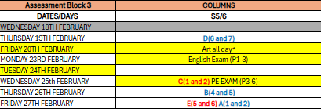

Subjects in each column:

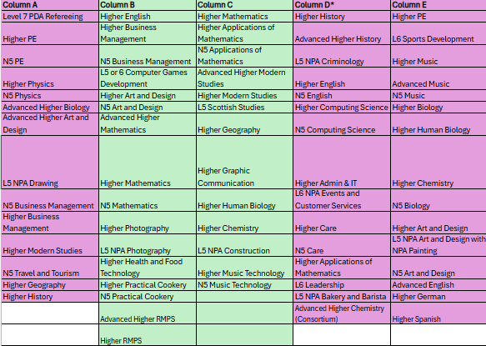

Assessment timetable by week:
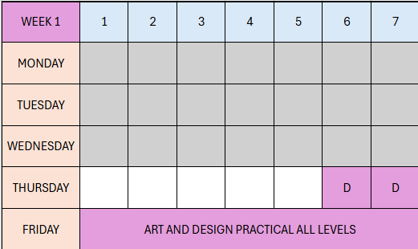
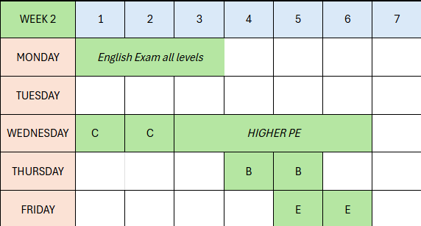
*Assessment Exceptions:
All Science and Maths assessments in every column will not take place until week commencing Monday 2nd March. They will take place in the allocated periods for the columns above.
Higher Music Tech will take place: Thursday 26th Feb P1 and 2
Higher Music will take place: Tuesday 24th Feb P1 and 2
Advanced Higher Music will take place: Friday 20th Feb P5 and 6
For English and PE exams, pupils should arrive at games hall a minimum of 25 minutes prior to paper starting to sign in.

Kind Regards
Debbie Martin
Debbie Martin
DHT Brodie House
