GLENIFFER HIGH SCHOOL  Amochrie Road  Paisley PA2 0AG  Tel: 0300 300 1313  Email address: glenifferhighenquiries@renfrewshire.gov.uk  Website: www.glenifferhigh.renfrewshire.sch.uk  Head Teacher: Lisa Chalmers | Children’s Services

Our Ref: DM
Date: 28/01/26

Senior Phase Assessment Block

Dear Parent/Carer,

The Third and final S4 Assessment Block will commence on the 19th of February.
Pupils will follow their normal school timetable and assessment blocks will take place during double periods in the subject which corresponds to their column choice outlined below. There are a couple of exceptions to this, given the nature of the assessment during this block and I have outlined these in this letter. During this assessment block, some assessments will take place in the games hall to provide pupils with the ‘exam experience’ ahead of the formal SQA diet.

Expectations:
- Pupils will not be given study leave for these exams and should follow their normal timetable when not undertaking an assessment.
- Pupils should be in full school uniform and come to exams readily equipped (pencils/pens/calculators as appropriate).
- These exams are under exam conditions and therefore pupils will not be allowed to have access to their mobile phones and or smart watches alongside personal belongings (bags/jackets etc.) these will be stored safely in the classroom away from their examination table.

All learners who are entitled to additional arrangements during assessment periods will have this factored into their examinations in class by their class teacher.

Help with studying approaches can be found via this link:
https://www.glenifferhigh.renfrewshire.sch.uk/news/get-exam-ready/

The best advice and support will come from their class teachers, this is where pupils should start with guidance on approaches for their subject area.

Assessment Calendar:
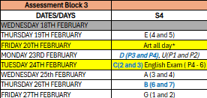

Subjects in each column:
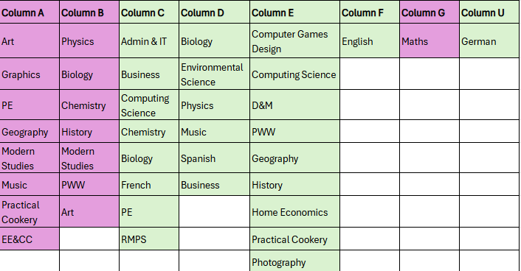

Assessment timetable by week:
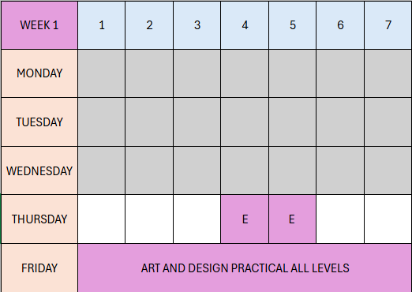
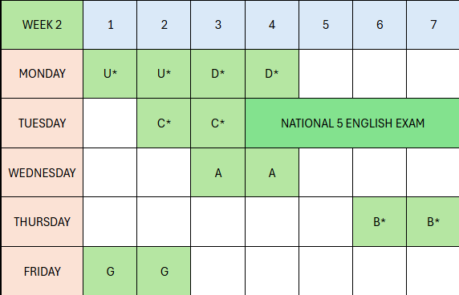

*Assessment Exceptions:
- Column B* - all subjects apart from Science to take place during this block. Science assessments to take place on Thursday 5th March Periods 6 and 7.
- Column C* – all subjects apart from Science to take place during this block. Science assessments to take place on Tuesday 3rd March. Column C Assessments will take place P2 and 3 which means through interval. Pupils will not be permitted to leave during their assessment and will receive a delayed interval on this day. Pupils should bring an appropriate refreshment to have during this day. Anyone who is entitled to free school meals will have access to snacks from the school canteen.
- Column D* - all subjects apart from Science to take place during this block. Science assessments to take place on Monday 2nd March Periods 3 and 4.
- Column U* - This is a small group of learners who are sitting National 5 German. This will take place in the German classroom during P1 and 2. Pupils will be extracted from their other subject for this double period only.
- English Assessment will take place in the exam hall. Pupils will be expected to arrive at 11:15am to sign in for this assessment outside the games hall.

On the adjacent page, the specific topics to be covered have been indicated to give direction into the areas to be covered for each subject assessment
If you have any further questions about this, please do not hesitate to get in touch.

Kind Regards
Debbie Martin
Debbie Martin
DHT Brodie House

